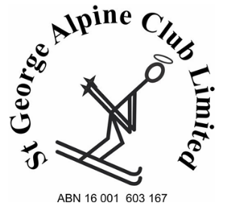
Lodge Membership Sale Transaction

Purpose:
To ensure every lodge membership transfer is treated as a formal transaction, fully evidenced, auditable, and capable of standing up to scrutiny as part of the club’s Constitution and (ClubMan) obligations.

Section A – Transaction Overview
Date transaction initiated
Effective transfer date
Membership type
Lodge / location
Nature of transaction | ☐ Sale ☐ Family transfer  ☐ Estate / deceased estate  ☐ Other:

Section B – Seller Information
Full legal name(s)
Current membership number(s)
Residential address
Contact details
(email and phone)
Seller Declaration: I confirm that I am the lawful holder of the above lodge membership/share and that I agree to transfer that membership/share on the terms set out in this document.
Seller signature: ________________________ | Date: ________________________
Print name: ________________________

Section C – Buyer Information
Full legal name(s)
Residential address
Contact details
(email and mobile / home phone)
Relationship to seller
(if applicable)
New membership number
(if already allocated)
Buyer Declaration: I confirm that I agree to acquire the above lodge membership/share on the terms set out in this document and acknowledge that it represents a share in St George Alpine Club.
Buyer signature: ________________________ | Date: ________________________
Print name: ________________________

Section D – Financial Details
Purchase price (AUD)
Payment method | ☐ Bank transfer / OSKO  ☐ Other:
Date funds transferred
Bank reference / transaction ID
Recipient of funds
Evidence attached | ☐ Bank transfer / OSKO receipt Number  ☐ Other proof: ____________________
No transaction may proceed without documented proof of funds

Section E – St George Alpine Club
Office Use Only
Membership Director, Checklist
Checklist item | Completed
Completed membership application form received | ☐ Yes ☐ No
Seller written confirmation of sale and receipt of funds received | ☐ Yes ☐ No
Buyer written acceptance received | ☐ Yes ☐ No
Proof of payment attached | ☐ Yes ☐ No
Secretary has been emailed with completed Lodge Membership Sale Form for ClubMan to record new membership | ☐ Yes ☐ No

